***Refrigeration Cycles***

* **Introduction:**

This cycle consists of four major components compressor, condenser, expansion device and evaporator.

* **Diagram:**

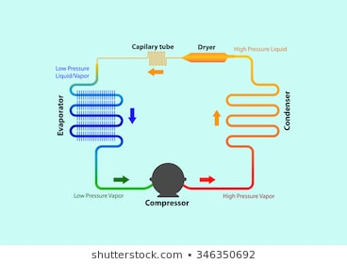

* **Working:**

During refrigeration cycle the compressor takes in refrigerant in the form in the form of a low pressure gas from the indoor evaporator coils. It compresses the refrigerant, turning it into a high pressure ,high temperature gas which then moves through the condenser coils that wrap around the compressor .The hot vapor then cools and condenses into a liquid as it flows through a coil, reacting with cool water or air. When the vapor condenses, it gives off heat to the outside air.

The liquid then moves to the expansion valve under high pressure. The valve restricts the liquid’s flow and rapidly lowers its pressure as it exits, causing it to be cooler than the space it is intended to refrigerate. Now at a low-pressure, the refrigerant moves to the evaporator, which absorbs heat from the outside air, and changes the liquid back to a gas.

At a cooler temperature and lower pressure, the gas is now at the perfect temperature to cool your home. As it circulates through the enclosed space, it moves back into the compressor where the entire cycle is repeated.

* **P-V Diagram:**

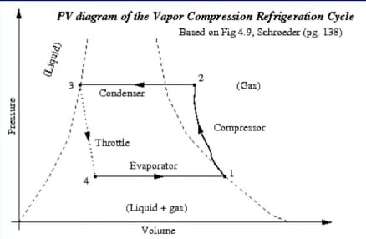

* **T-S diagram:**

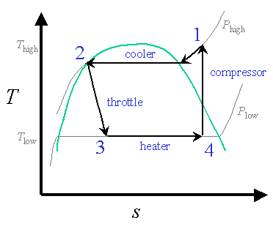

* **Applications:**

Its applications are not only in household process it is also used in industrial freezers, cryogenics and air conditioning. Heat pumps may use the heat output of the refrigeration cycle.